

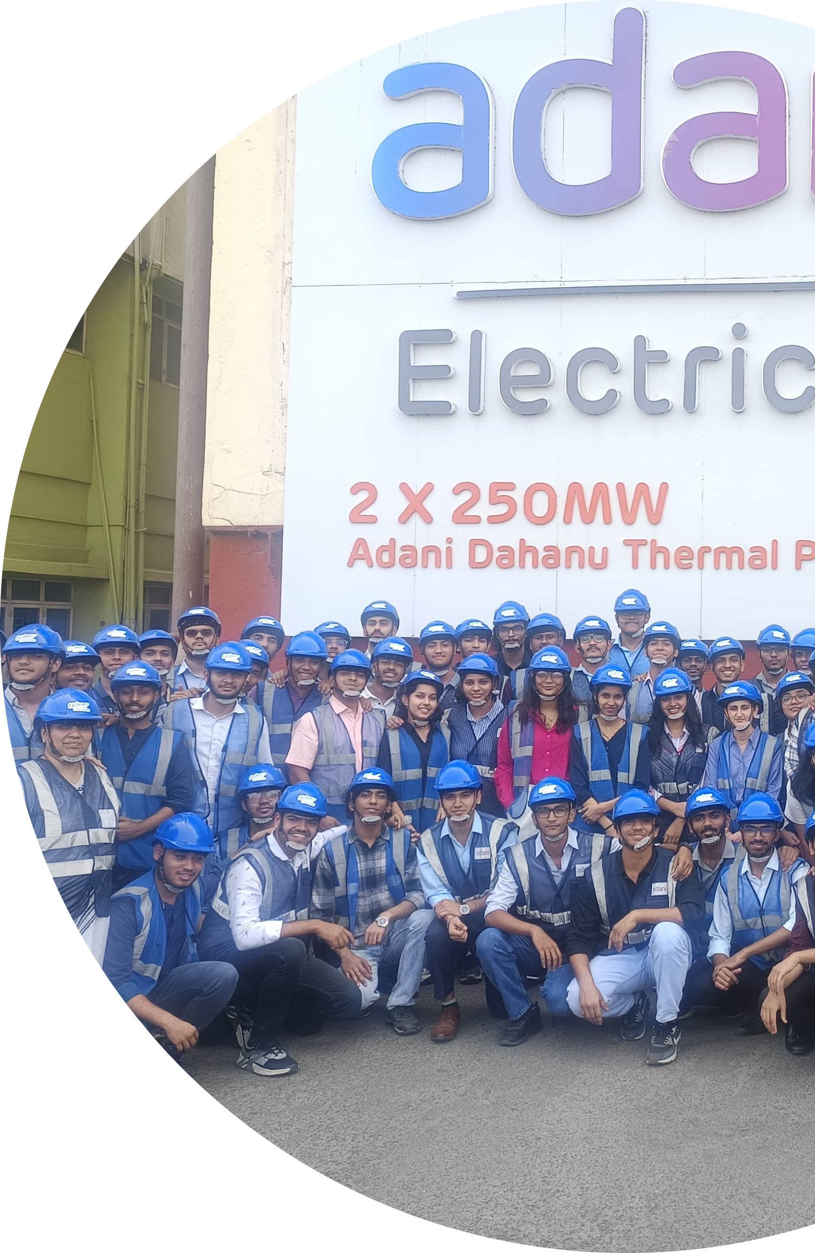

INDUSTRIAL VISIT

**REPORT**

2025

9881 X 9914

**TE Comps A**

9913



**IOT ISE1**

BSES colony, Dahanu, Maharashtra 401608

Industrial Visit Documentation

January 15, 2025

Overview

In this report I will be talking about the industrial visit scheduled by our college, Fr. Conceicao Rodrigues College of Engineering , to the thermal power plant of the adani company at dahanu

road. The visit was aimed at informing us about the use of software related technology in the working of the power plant.

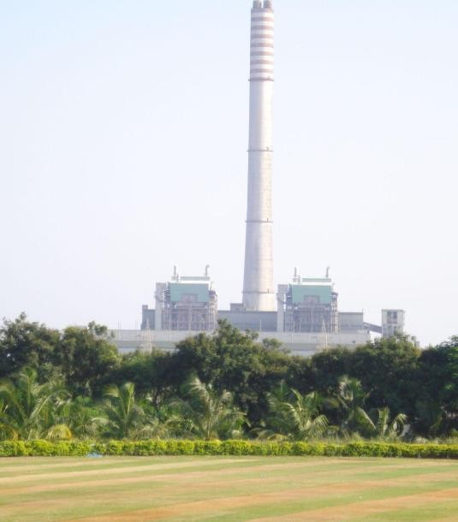

# Brief History, Capacity, and Key Operations

The Dahanu Thermal Power Station is located in Dahanu town in Maharashtra's Palghar district. It was commissioned in 1995. It comprises two units, each with a capacity of 250 megawatts (MW), totaling 500 MW. Initially constructed by BSES Limited, the plant is currently operated by Adani Electricity Mumbai Limited.

The facility utilizes coal as its primary fuel source,procured from South Eastern Coalﬁelds

Limited.

1

# Importance of the Power Plant in the Energy Sector

The Dahanu Power Plant plays a crucial role in supplying electricity to Maharashtra, particularly the Mumbai region. Its strategic location along the Mumbai-Ahmedabad rail line facilitates eﬃcient coal transportation and power distribution. By contributing 500 MW to the grid, the plant helps meet the region's energy demands, supporting residential, commercial, and industrial activities.

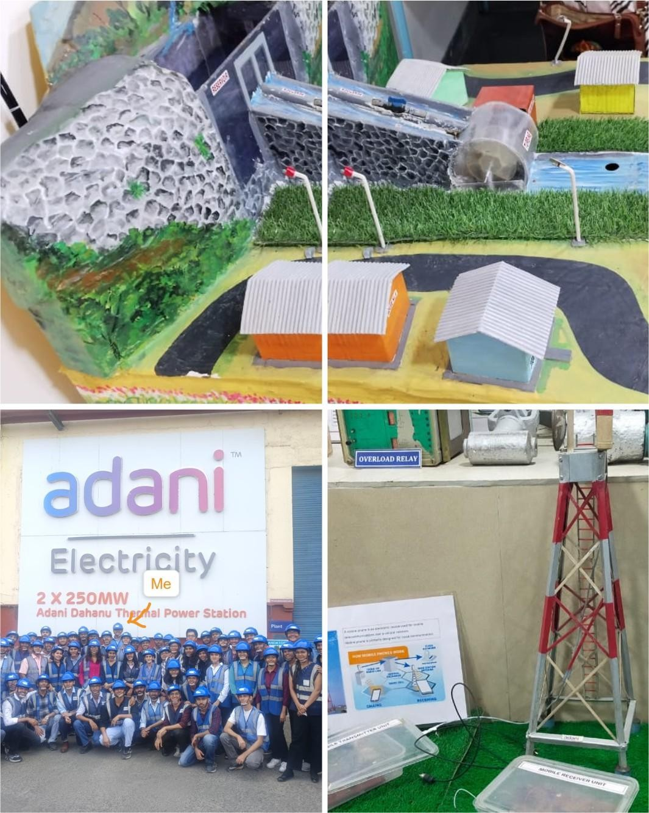

# The IoT Technologies and Sensors Used in the Power Plant

Sensors are deployed to monitor various things such as temperature, pressure, vibration, and emissions. These devices collect real-time data, which is transmitted to centralized systems for analysis. Common IoT technologies include smart meters, advanced control systems, and predictive maintenance tools.

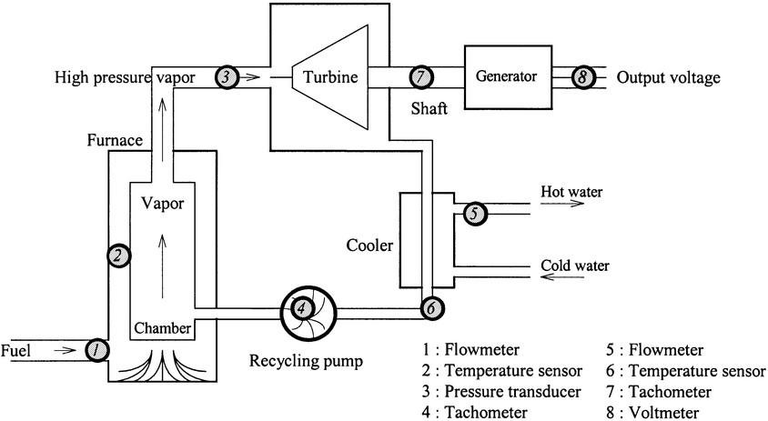

# How IoT Aids in Monitoring, Automation, and Real-Time Data Collection

IoT allows for the continuous monitoring of equipment and processes in the power plant.

Real-time data collection enables immediate detection of anomalies, which can be responded to promptly. Automation systems can adjust operations based on sensor inputs, optimizing performance without human intervention. This approach enhances reliability and safety while reducing the likelihood of human error.

For eg: Imagine I am operating a boiler in the Adani Dahanu Power Plant. The boiler heats water to produce steam, which drives a turbine to generate electricity. Now, maintaining the right temperature, pressure, and water level is critical for safety and eﬃciency.

* Without IoT (Traditional Monitoring Method): A technician manually checks the temperature and pressure readings at regular intervals (e.g., every hour).

If a problem occurs suddenly, like pressure increasing too much, the technician may not notice it immediately, leading to equipment damage or even an explosion.

* With IoT (Smart Monitoring & Automation): Sensors are installed on the boiler to continuously measure temperature, pressure, and water level in real time. The data is sent to a centralized system (e.g., a control room computer) where AI and automation analyze it.

# Speciﬁc Use Cases

## Predictive Maintenance:

1. **Emissions Control**

Continuous monitoring of emissions ensures compliance with environmental regulations. IoT systems can trigger alerts or adjustments to operations if emission levels approach predeﬁned limits.

## Energy Eﬃciency

IoT devices monitor energy consumption patterns, identifying areas where eﬃciency can be improved, leading to cost savings and optimized resource utilization. A traditional cycle is shown below.

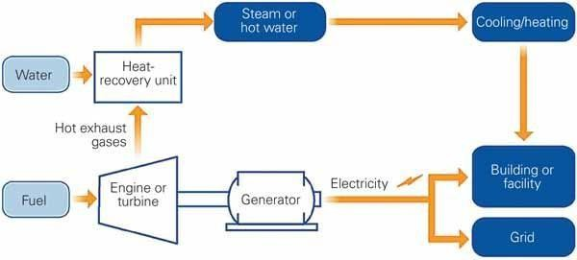

# How Does IoT Enhance Operational Eﬃciency and Reduce Costs

IoT integration streamlines operations by providing detailed insights into plant performance. Automated systems can make real-time adjustments to optimize processes, reducing waste and energy consumption. Predictive maintenance minimizes unplanned outages, lowering maintenance costs and extending equipment lifespan. It also helps the customer side as shown in below ﬁgure as well.

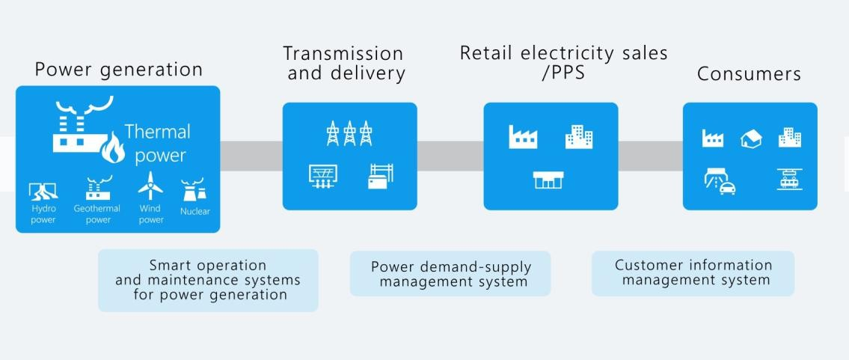

# Impact on Sustainability and Environmental Compliance

IoT helps reduce the environmental footprint of the plant with precise control of operations. Using energy eﬃciently along with monitoring emission effectively, supports sustainability goals as well as satisﬁes environmental standards.

Challenges: The Sir there said that in dahanu road plant; as its the oldest of adani plants; theres currently not much IOT implementation in place instead the work is done manually by workers due to old infrastructure so we’ll need to upgrade the infrastructure. There are also many other challenges like introducing new technology with the existing system data security, and gigabytes of data production.

Suggestions: The main thing is to upgrade the infrastructure ﬁrst because implementing an IOT system from scratch will require newer infrastructure. The rest changes can be done by an IOT team in phases.

# Conclusion

Adani Dahanu Power Plant is an example of how modern IoT technologies can beneﬁt traditional power generation facilities by enhancing eﬃciency, reducing costs, and increasing environmental compliance.

# References:

* 1. **Wikipedia** (en.wikipedia.org)
  2. **Power Technology** (power-technology.com)
  3. **Infopulse** (infopulse.com)
  4. **MindK** (mindk.com) Images:
  5. **https://**[**www.google.com/url?sa=i&url=https%3A%2F%2Fen.wikipedia.org%2Fwiki%2FD**](http://www.google.com/url?sa=i&url=https%3A%2F%2Fen.wikipedia.org%2Fwiki%2FD) **ahanu_Thermal_Power_Station&psig=AOvVaw1-_Vg9I3bIms7JZvuZYzty&ust=1738352 924539000&source=images&cd=vfe&opi=89978449&ved=0CBQQjRxqFwoTCKju8bWb nosDFQAAAAAdAAAAABAE**
  6. **https://psiborg.in/wp-content/uploads/2024/01/Predictive-Maintenance-Fb.webp**
  7. **https://**[**www.powermag.com/wp-content/uploads/2010/02/520004da9dede-020109_Pl**](http://www.powermag.com/wp-content/uploads/2010/02/520004da9dede-020109_Pl)

**antEﬃciency_Fig1.jpg**

* 1. **https://encrypted-tbn0.gstatic.com/images?q=tbn:ANd9GcRFeL5HmkkZequk3lSFFnFq wU2ADQCjMKQWZg&s**